# DEMO 3 model

Model in DEMO 1 and DEMO 2 do not allow for any scarcity, i.e. if the available level of supply is lower than the required level of demand (represented by lower bound of water delivered via links to each demand node), both models become infeasible and no solution can be reached. We therefore modify the previous model formulation to allow for water shortage so that infeasibilities are not generated. The available water, even when lower than the target demand, will be distributed to demand nodes with higher priority (cost) first and then to those with lower priority.

To do so, a new decision variable *αit* (i.e. demand satisfaction ration) is introduced and defined for each demand node (set *DEM*) that is equal to one if the demand is fully met and lower than one (with a minimum value of zero), if only a percentage of the target demand is met.

|  |  |
| --- | --- |
| $$0≤α_{i}^{t}≤1 ∀i∈DEM,t∈T$$ | 1 |

The new objective function now becomes:

|  |  |
| --- | --- |
|  | 2 |

In the formulation presented in this report, all decision variables are in capital letters while input data are in lower case. The objective function maximises the level of demand satisfaction for each time-step *t* for all demand nodes (*i*) based on the priorities *pit*. Since we are now dealing with a maximisation problem, the higher *pit* the higher is the priority for each demand node to receive water.

The objective function equation 2 is subject to the constraint equation 1, mass balance for non-storage nodes (Set *NS*) (equation 3), mass balance for storage nodes (set *ST*) (equation 4), and lower and upper bound constraints (equations 5 and 6). With regards to the non-storage nodes, the mass balance equation becomes:

|  |  |
| --- | --- |
|  | 3 |
| ${inflow}_{i}^{t}+\sum_{j}{\left({a_{i,j}}^{t}{X_{i,j}}^{t}-{X_{j,i}}^{t}\right)}+S_{i}^{t}-S_{i}^{t-1}=0 ∀t∈T,i∈S$*T* | 4 |
| $$0≤{{lq}_{i,j}}^{t}≤{X_{i,j}}^{t}≤{{uq}_{i,j}}^{t} ∀t∈T,(i,j)∈CON$$ | 5 |
| $0≤{{ls}_{i}}^{t}≤{S_{i}}^{t}≤{{us}_{i}}^{t} ∀t∈$*T $, i∈S$ T* | 6 |

In the equations above, for each time-step t, ${inflow}_{i}^{t}$ is the inflow incurred for each node, ${X_{i,j}}^{t}$ is the flow to be optimally determined in each link, ${a_{i,j}}^{t}$ is the flow multiplier in each link representing losses in flow due to evaporation, seepage, etc., $d_{i}^{t}$ is the target demand value for each demand node, $S_{i}^{t}$ is the storage capacity in storage nodes, ${{lq}_{i,j}}^{t}$ and ${{uq}_{i,j}}^{t}$ are the lower and upper bound on flows in links respectively, and ${ls}_{i}$ and ${{us}_{i}}^{t}$ are lower and upper bound on storage values respectively.

## Example exercise

This model has been applied to network in the figure below. The network is composed of four demand nodes (i.e. Urb1, Urb2, Ag1, Ag2, and the Endpoint which is of agricultural type), five storage nodes (i.e. SR1, SR2, SR3, SR4, GW1, GW2, Desal1), one hydropower plant (i.e. Hp1), and one waste water treatment plant (i.e. WWTP1). J1, J2, and J3 are junction nodes.

The model is run for each individual time step *t* independently (9 time steps in total). Only the storage ($S_{i}^{t}$) depends on the level of storage at previous time steps according to equation 4. At each time step the models determines the optimal level of allocation of water to the demand nodes, based on pre-defined priorities.

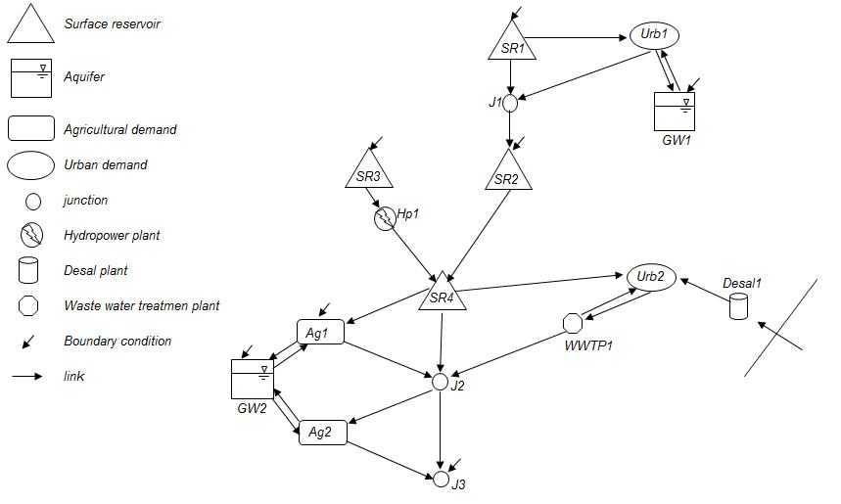

Model input data are presented below for nine time steps. These data include priorities of allocation on each demand node, lower/upper bound on the storage capacity, lower/upper bound on flow capacity in each link, flow multiplier for each link, inflow to the storage nodes, and target demand value for each demand node.

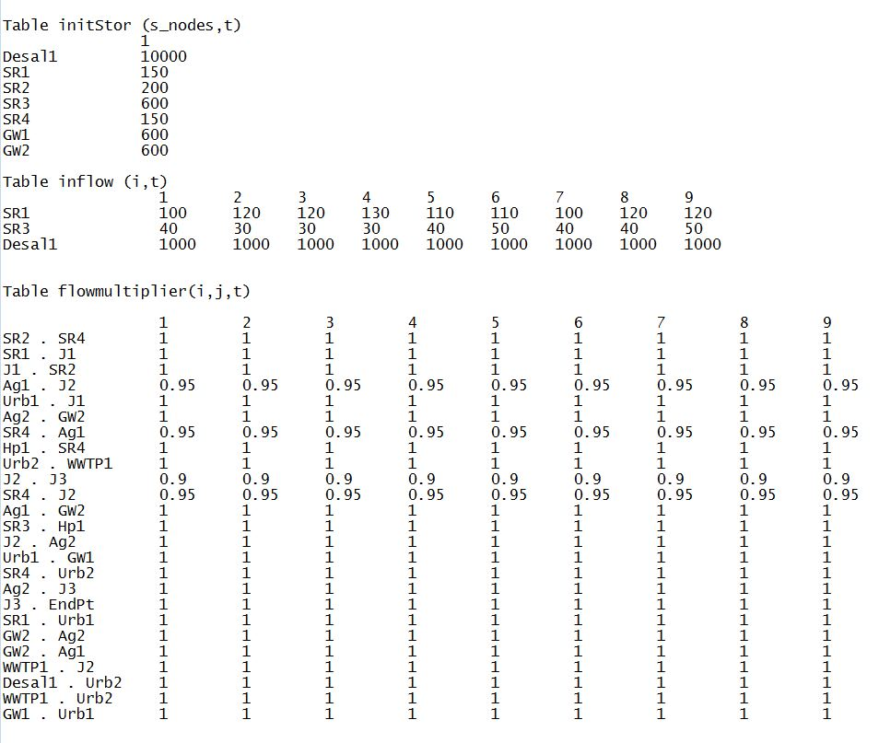

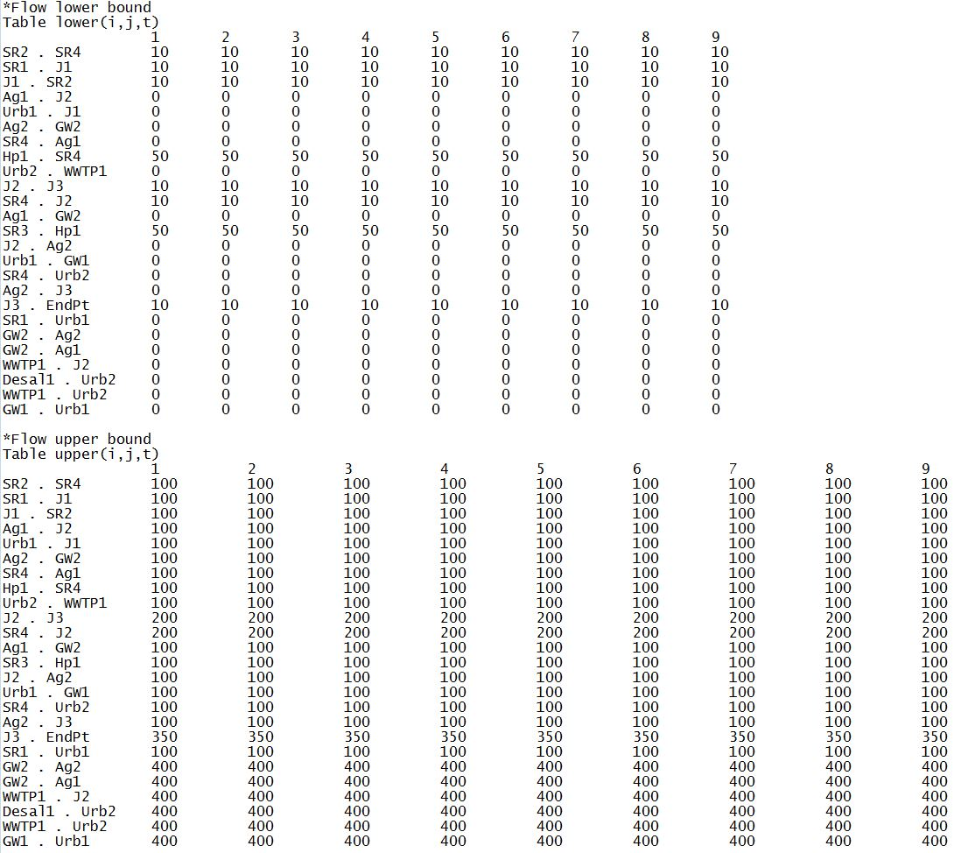

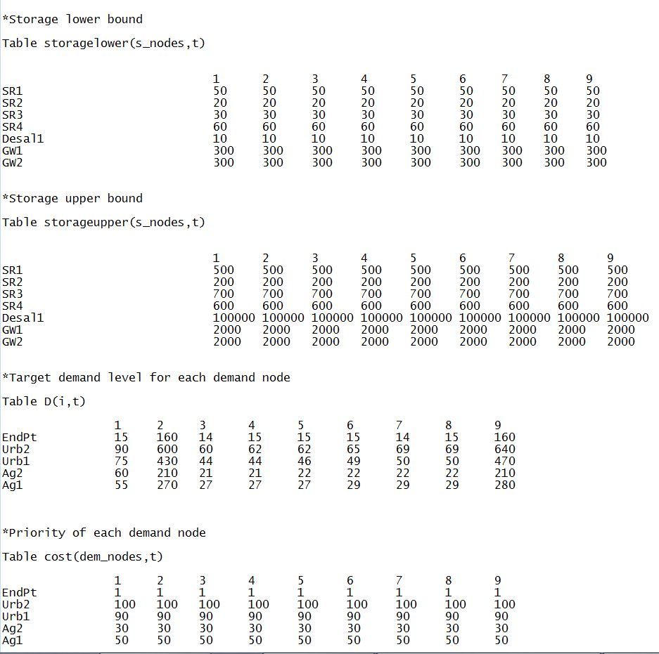

## Input data structure

Hydra can be used as a data management tool for any network modelling problem as in Demo 3. Input data presented in the previous section will be restructured in order to be hydra-compatible. This will also require reformatting some of the syntax in the GAMS code. Input data in section above are re-written in the format shown in figure below. Note that, due to brevity, only part of the reformatted data is shown in figure below as an explanatory example (i.e. target demand levels and priorities, which are defined over demand nodes). All remaining parameters also follow the same structure.

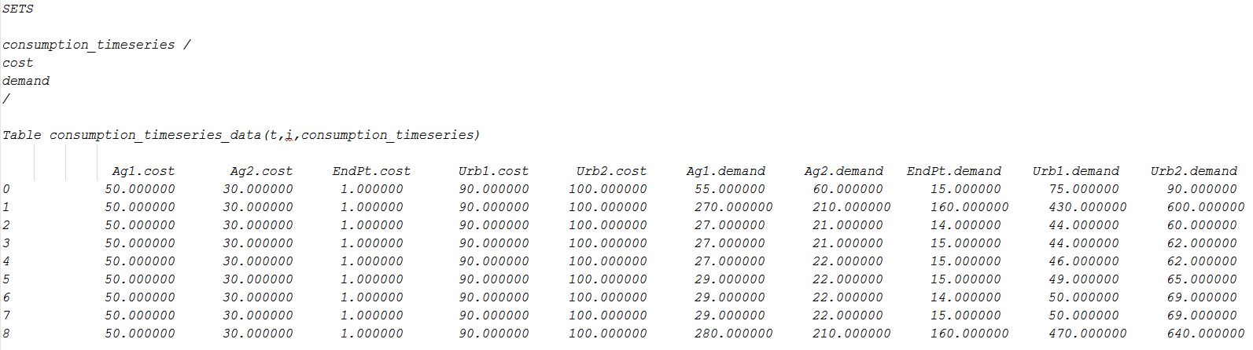

## Results and Discussion

The amount of target demand for demand nodes significantly increases in the second and last time step (see tables above). This increases the chance of scarcity in the water system and also infeasibility. But as said before, Demo 3 model can handle such situations. So the question that arises is how the model allocates water in case of scarcity. Demo 3 allows allocation of water even in case of scarcity (such feature was not addressed in demo 2 model). Results from applying Demo 3 to the example network, are shown below.

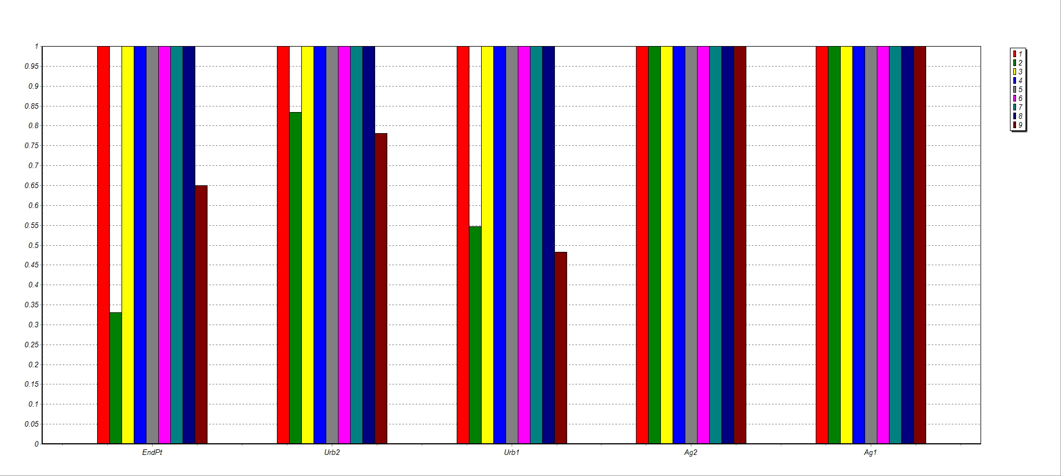

For simplicity, we only show and discuss the value of the demand satisfaction ratio (*αit*) for each demand node *i* and time step *t*. With increased amount of target demand for the second and ninth time step, ‘Urb2’ receives more water than ‘Urb1’ and ‘Endpt’ based on their priorities. ‘Ag1’ and ‘Ag2’ meet their full demand since the total upper bound capacity on the incoming links is higher than the required level of demand. This is not the case for urban node ‘Urb2’, where upper bounds on links limit the amount of water allocated, even if there is enough supply from the storage node ‘Desal1’. The percentage of demand satisfaction (*αit*) for this node is equal to 83% and 78% for time step 2 and 9 respectively. Scarcity also occurs for demand nodes ‘Urb1’ and ‘Endpt’, for which *αit* is equal to 54% and 33% for time step 2 respectively and equal 48% and 65% for time step 9 respectively. The level of demand satisfaction at time step 2 is higher for ‘Urb1’ than ‘Endpt’. This is because ‘Urb1’ has a higher priority than ‘Endpt’. This does not occur at time step 9 because of the lower bound capacity set on storage for node ‘GW1’ (much of the available water is kept to meet the lower bound constraints, i.e.300 ).

Therefore, in summary, Demo 3 model allocates scarce water to demand nodes based on priorities and given limitations on links/storage capacity (upper/lower bound constraints). Such limitations represent possible political, social and environmental restrictions. Another advantage of Demo 3 is that it easily allows assigning priorities, one number for each demand node. On the contrary, in Demo2, priorities were assigned to all links/arcs, and in case of large networks, one would need to specify priorities for large number of links. It would also be difficult to predict how the model would allocate water along all the links (i.e. what would be the path with total higher priority?).